Answer to question 2:

1. I learned a little bit about Eiffel Tower when I was taking Architecture class few years ago. I know that Eiffel Tower is made of puddling iron, and according to data online, building the Eiffel Tower used about 7000 metric tons of puddling iron, which is:

Assuming the geomag pieces we are using all have same size (let’s say about ), then:

Therefore, we may need about 1113231155 pieces of Geomag. However, this is only for BUILDING the Eiffel Tower only. If we are assuming that no other superheroes will be involved to help us, and we would use the exact same way how the Eiffel Tower was built. We will need to consider about how many materials (Geomag in this case) will we need to build the part where it can support the first platform of the Eiffel Tower first, since building from those 4 legs will definitely have some obvious engineering problems (They won’t be strong enough to stand up on its own). We will do the same for the second platform. (The 1st and 2nd platform will be shown on the blueprint picture.) Therefore, my estimate will be about in total. During the process of Eiffel Tower’s construction, the tower will become higher and higher. The wind will inevitably make the tower move slightly. Therefore, we will probably build another pillar at the center of Eiffel Tower to support its body.

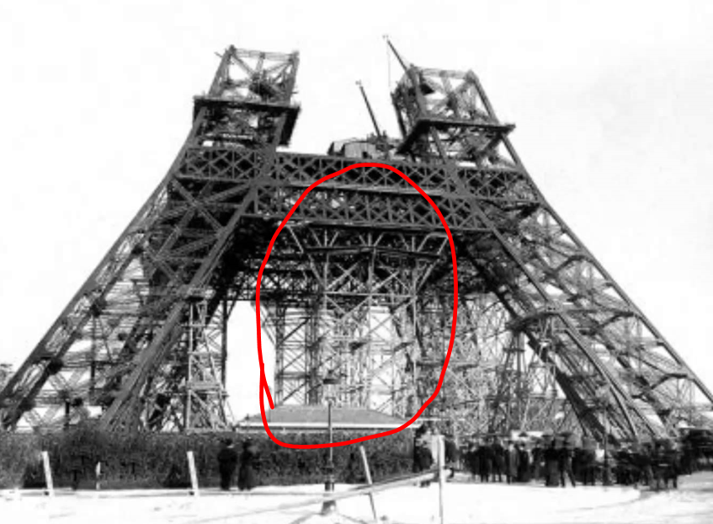

Possible improvement:

Since we are dealing with Geomag, a magnetic construction toy. The Geomag bars will have a magnet n each end attached by a magnetic plug, and nickel-coated metal spheres. My idea is to bury 4 giant chunks of magnet in the ground below each foot of Eiffel Tower. It can help reinforce the Eiffel Tower to prevent environmental disaster at least.

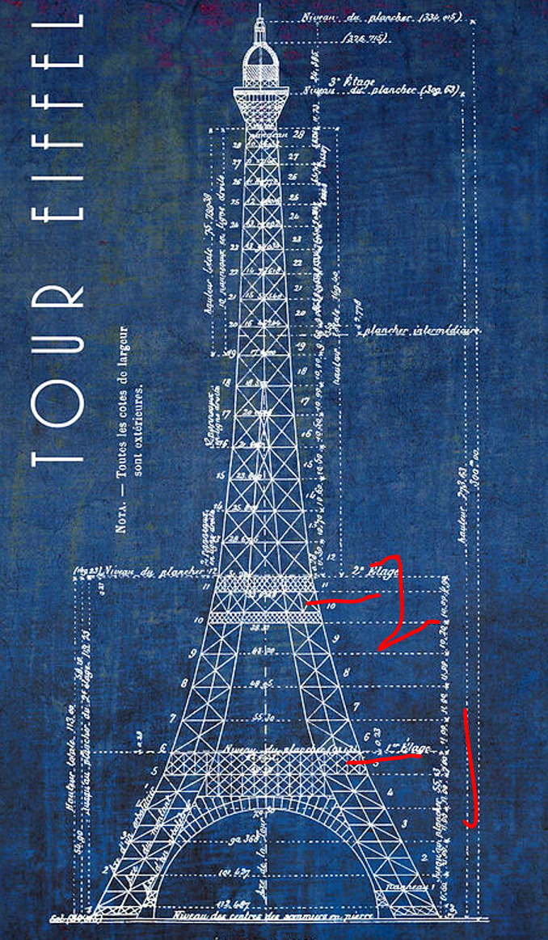

A better answer:

We are in Marvel Universe, right? So here’s the instruction:

1. Beat up Thanos and get the infinity gauntlet.
2. Use the capability of Time Gem to rewind
3. An Eiffel Tower that’s not destroyed!
4. Geomag used: 0!